Cairo University  
Faculty of Computers and Information



**CS251**

**Software Engineering I**

**-Social Network-**

**Software Requirements Specifications**

No Name

**November-2019**

Contents

Team 3

Document Purpose and Audience 3

System Models 3

I. System Decomposition 3

II. Class diagrams 6

Important Algorithm 7

III. Sequence diagrams 7

Class - Sequence Usage Table 9

Ownership Report 10

Policy Regarding Plagiarism: 10

References 10

Authors 10

# Team

|  |  |  |  |
| --- | --- | --- | --- |
| **ID** | **Name** | **Email** | **Mobile** |
| 20170058 | Alaa Farouk AbdElmajied | Alaafar19@gmail.com |  |
| 20170207 | Maria Emil William | Mariaemil55@gmail.com |  |
| 20170311 | Nardine Nabil Gadallah | Nardine1nabil@gmail.com |  |
| 20170325 | Nour Atef Radwan | Nour.atef369@gmail.com |  |

# Document Purpose and Audience

* This document is presenting a software requirements specification, which is a description of a software system to be developed, laying out functional, nonfunctional requirements, and system models. It is for a back-end API (Application Programming Interface) for a Social Network, which is a dedicated website which enables users to communicate with each other by posting information, comments, messages, images, like Facebook, etc..
* It targets developers (to be able to maintain or develop functions), software engineers and business developers who are trying to develop their professional network or create a new one.
* It targets also the project manager, who is responsible for the whole project.

# System Models

## I. System Decomposition

* **Provide and describe a figure that depicts the overall system decomposition.**
* **Read about “Software Coupling and Cohesion” Concepts. Reflect that in model**
* **The three following images from web are for purpose of explaining. First one is how model is designed, but there are little connections (so it is not so good).The other two ones have better connection. Consider the 3 to know how a good model should be.**
* **Remove these images from your report and draw your own system decomposition.**

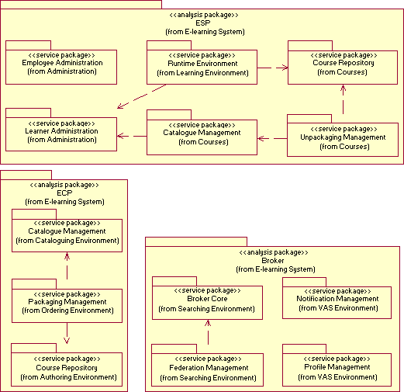

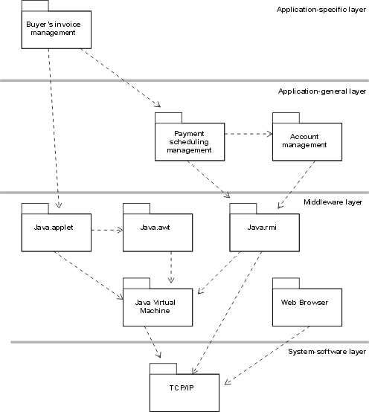

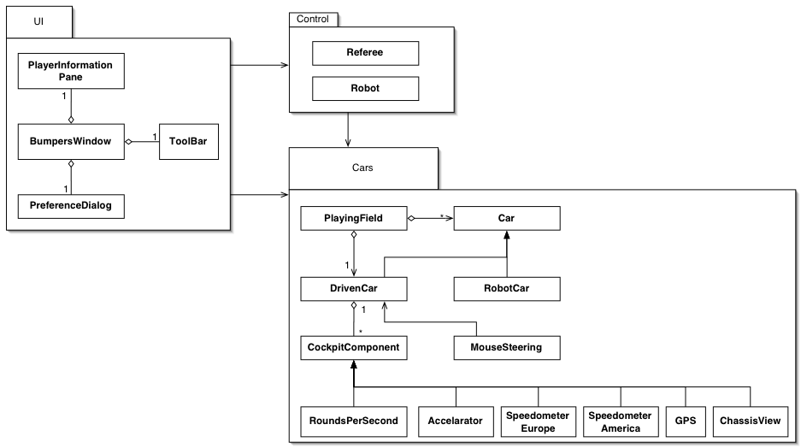

## II. Class diagrams

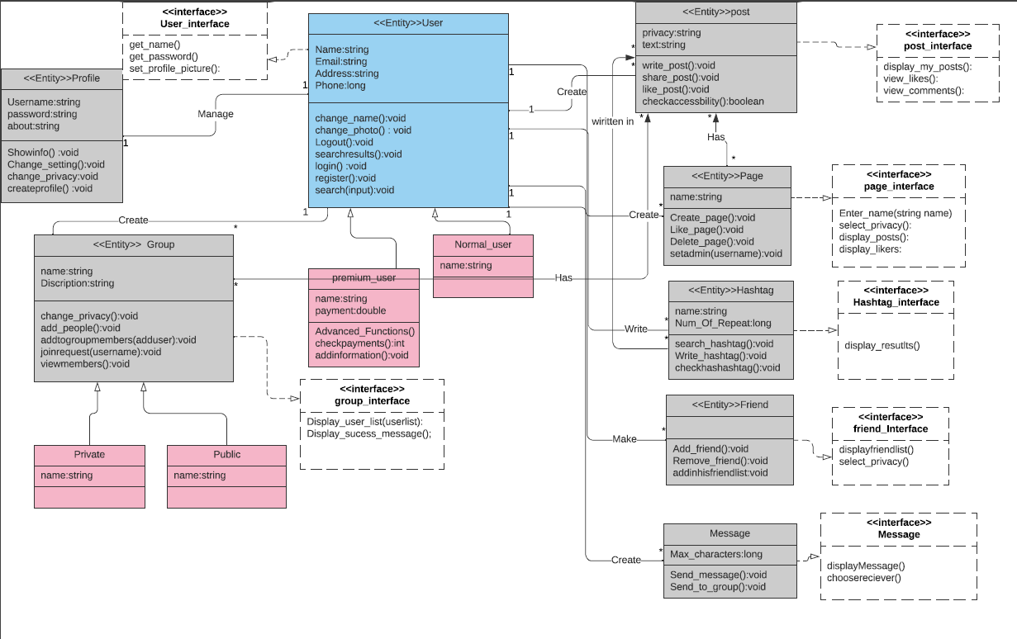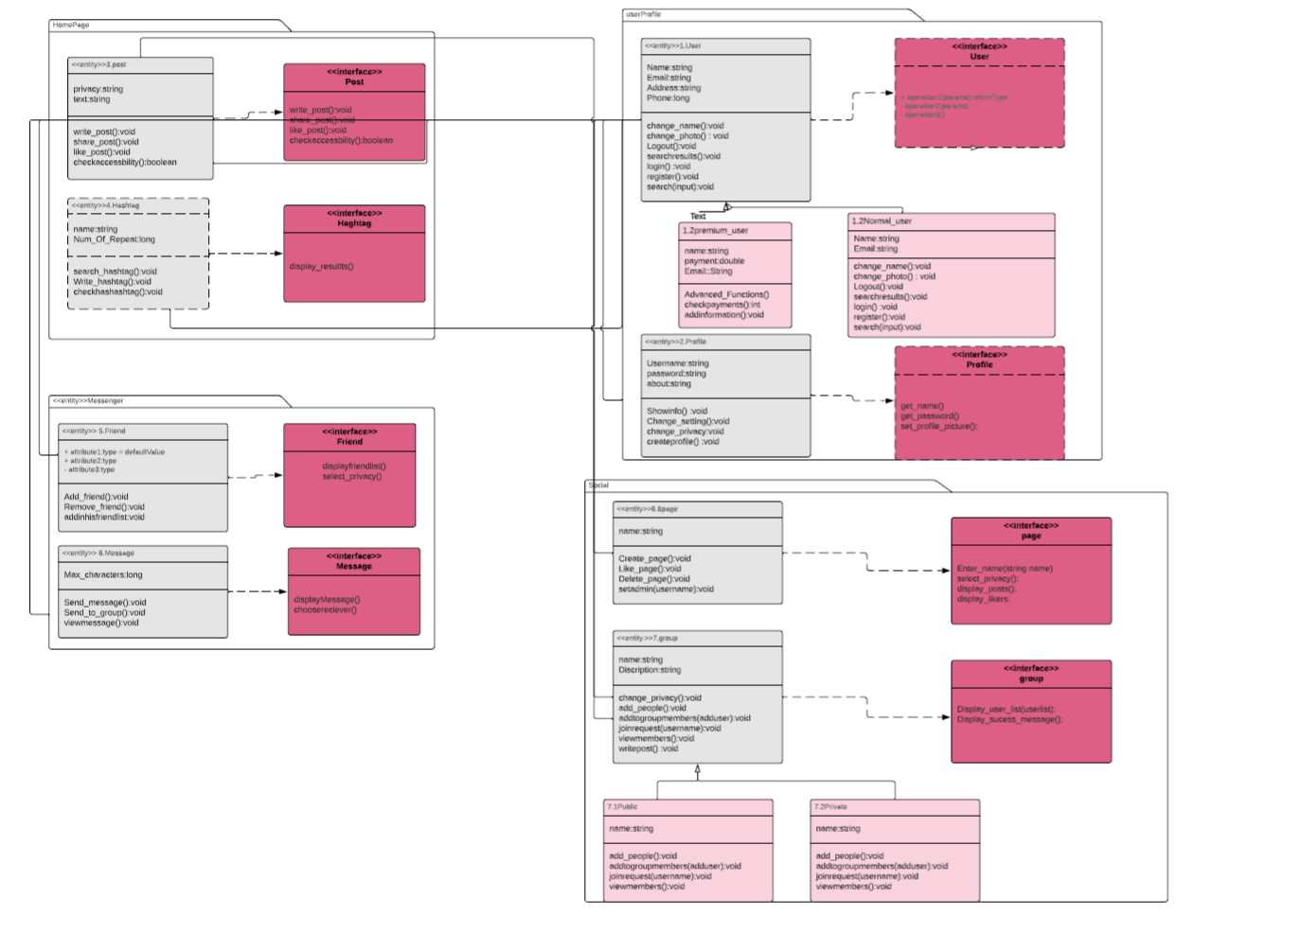

| **Class ID** | **Class Name** | **Subsystem ID** | **Description & Responsibility** |
| --- | --- | --- | --- |
|  |  |  |  |

## 

## III. Sequence diagrams

1.signup

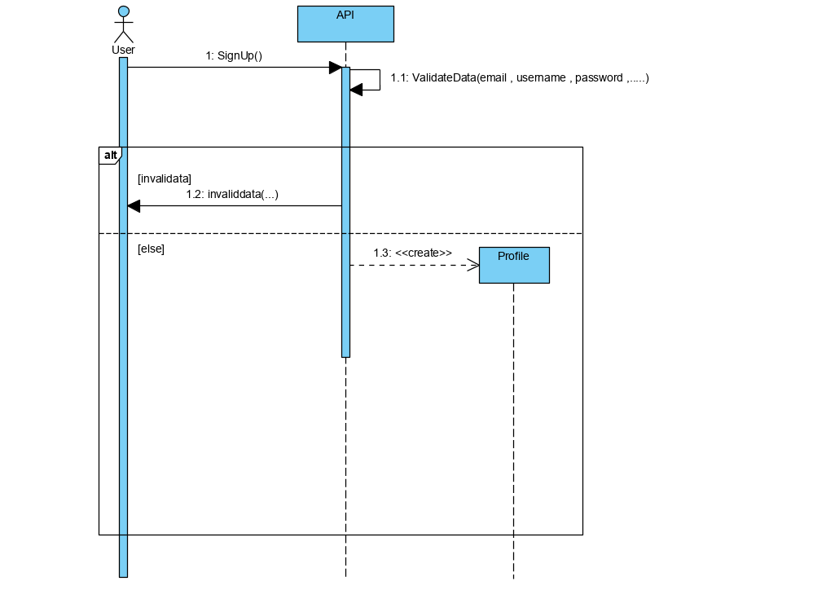

1. Sign with advanced features

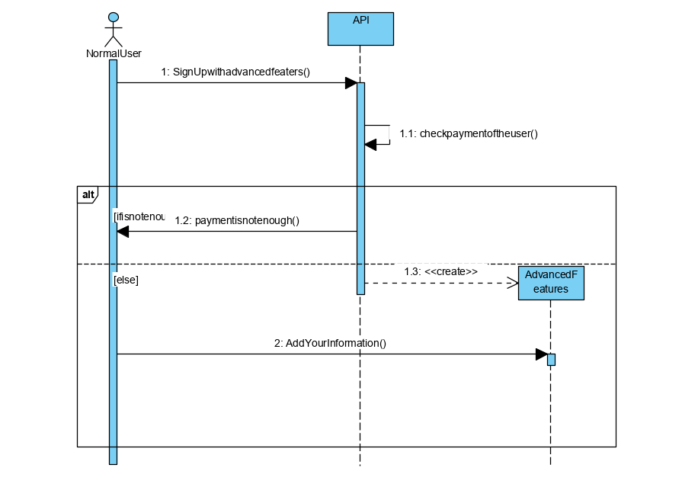

### 

### 3.log in

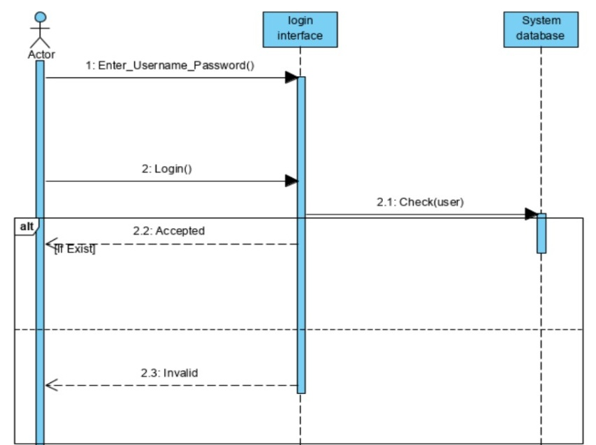

1. Message 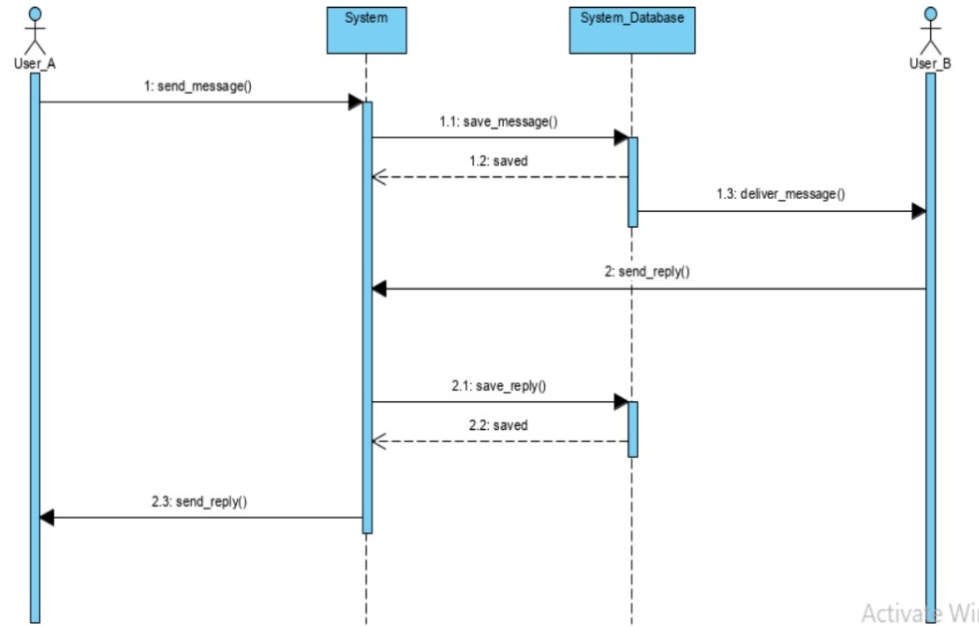
2. Addfriend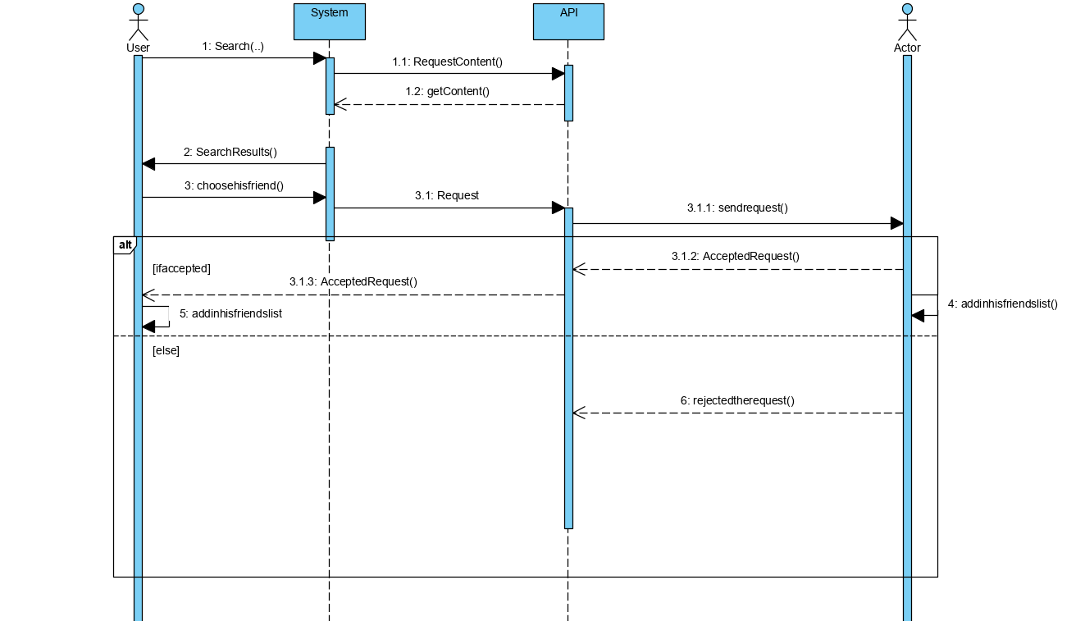
3. Create group

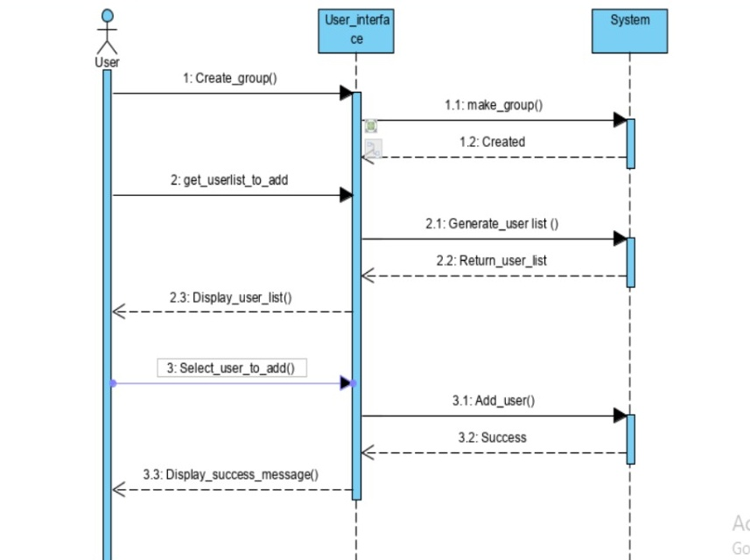

1. create page 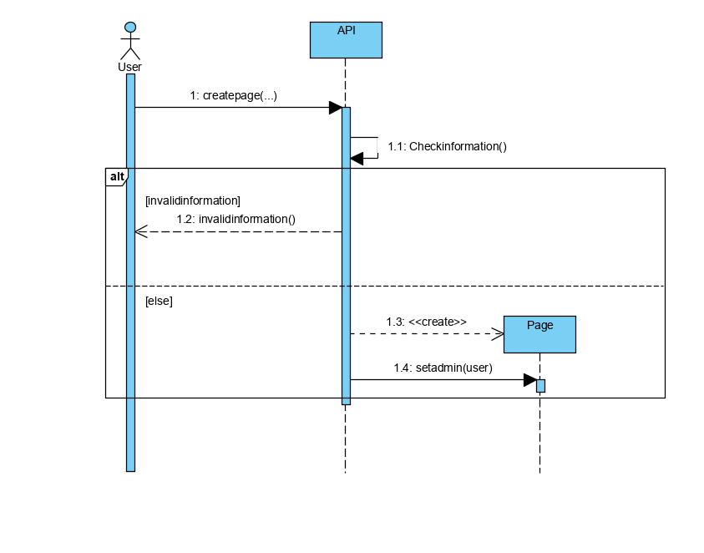
2. joingroup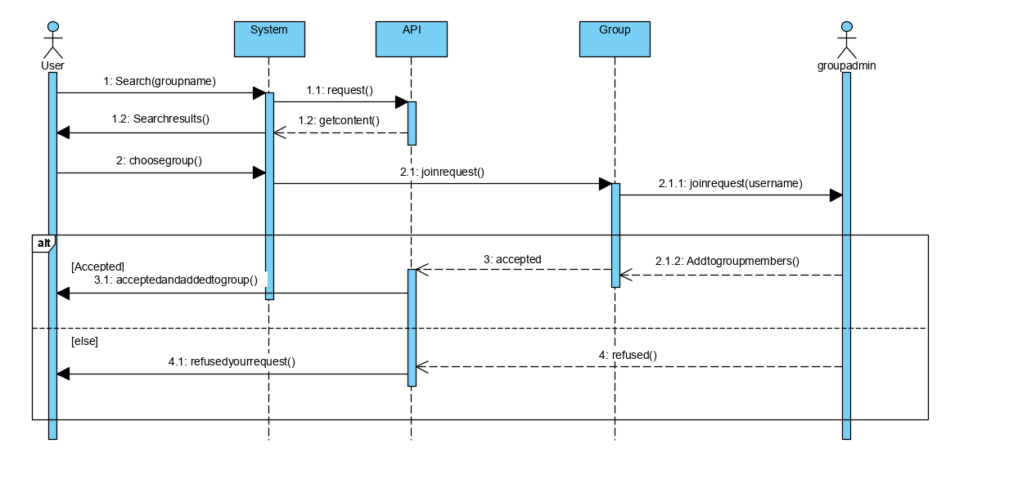 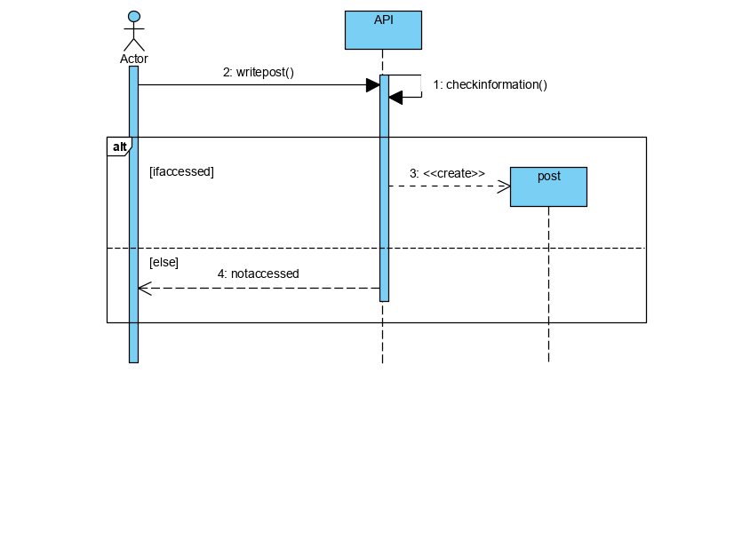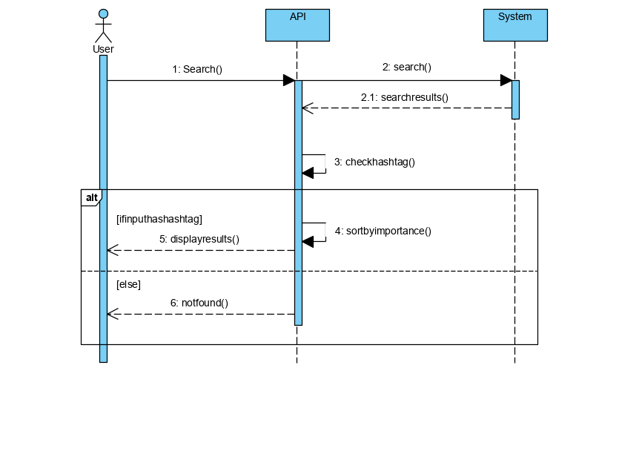

### Class - Sequence Usage Table

| **Class Name** | **Sequence Diagrams** | **Overall used methods** |
| --- | --- | --- |
| User | 1,2,3,4,5,6,7,8,9,10 | Search , sign up , login ,search results ,show information |
| Premium user | 2 | Sign up with advanced features |
| Post | 9 | Write post |
| Group | 5,7 | Join request , create group , add to group members , make group |
| Hashtag | 10 | Search , write input ,check has hashtag |
| Message | 3 | Send message , deliver message |
| Profile | 1 | Create profile |
| Page | 6 | Set admin |
| Friend | 4 | Add in his friend list , add friend |

# Ownership Report

* **Remove the following notes and any red notes**
* **For every item in this document, write the owners. If someone is owner of something, s/he understands it 100.%**
* **Team leader must verify the table with the team members.**

|  |  |
| --- | --- |
| **Item** | **Owners** |
|  |  |
|  |  |

# 

# Policy Regarding Plagiarism:

1. تشجع الكلية على مناقشة الأفكار و تبادل المعلومات و مناقشات الطلاب حيث يعتبر هذا جوهريا لعملية تعليمية سليمة
2. ساعد زملاءك على قدر ما تستطيع و حل لهم مشاكلهم فى الكود و لكن تبادل الحلول غير مقبول و يعتبر غشا.
3. أى حل يتشابه مع أى حل آخر بدرجة تقطع بأنهما منقولان من نفس المصدر سيعتبر أن صاحبيهما قد قاما بالغش.
4. قد توجد على النت برامج مشابهة لما نكتبه هنا أى نسخ من على النت يعتبر غشا يحاسب عليه صاحبه.
5. إذا لم تكن متأكدا أن فعلا ما يعد غشا فلتسأل المعيد أو أستاذ المادة.
6. فى حالة ثبوت الغش سيأخذ الطالب سالب درجة المسألة ، و فى حالة تكرار الغش سيرسب الطالب فى المقرر.

# References

* http://www.mhhe.com/engcs/compsci/pressman/graphics/Pressman5sepa/common/cs1/design.pdf

# Authors

* Mostafa Saad and Mohammad El-Ramly